**How Success is Distributed Across Hockey Periods**

**Literature Review**

HockeyViz is a popular website that contains articles, speeches, and presentations relating to hockey analytics. An article from HockeyViz, written by Micah Blake McCurdy, describes the sequence in goals that are scored and how that impacts a given game (McCurdy). He found that a team that attempts to kill time tends to have more of an effect on score sequencing than a team only pushing for another goal. The graphs provided in his article analyze the threat of score sequencing by game period. As such, the threat levels vary by what instances of scoring were being examined.

From analyzing this article, I seek to examine in what period a team’s threat is the greatest. This question could be asked in all sports, but there is very limited information in this area. Many people have studied one aspect of hockey, such as score sequencing by period, but I found no articles that asked that of every event in a hockey game.

Threat and success are only analyzed through the lens of goals and goal scoring in McCurdy’s study. The data presented for the Big Data Cup 2021 is every event within a set or season of hockey games. I believe that threat should be determined by success, and while a team’s goal is to score, there are many more successful events in a game than a goal. For the purposes of this study, success will be defined as “any event with a positive outcome for a team,” and a team is considered unsuccessful when there is a negative event that occurs.

For the intent to condition players more accurately and stress the importance of time in a game, this study will analyze the effect of success by period. As a baseball player and coach, I stress the importance of scoring first to both my teammates and players because it can create insecurity in opponents and impact early game confidence. For this reason, I hypothesize that success and threat are greatest in the period that the first goal is scored.

**Methods**

**Design and Participants**

This study utilized an exploratory approach on a given data set for the minor league hockey team, the Erie Otters. Due to the focus on one team, I could not use an analysis by team, as the data set would be biased, and the only relevant results would be for the Erie Otters. By choosing a comprehensive analysis of success and threat by period for all teams, I was able to eliminate any unintentional bias within the data set.

**Procedure**

Some events in each game clearly have a positive outcome. These events are goals, plays, takeaways, puck recoveries, faceoff wins, and zone entries. All of these events are the intent of the skaters, and either grant their team possession of the puck, advance their team into scoring position, or are goals themselves. Other events such as a dump in/out or a shot are not clearly positive or negative. They are the skater’s intent, but there are multiple outcomes that can either be beneficial or disadvantageous to a team. Other events are clearly negative, such as a penalty taken and an incomplete play, as they put their team at a disadvantage in number of skaters or grant the opposing team possession of the puck.

Based on these clear outcomes, each entry was factored into a category of success, with the factors “successful,” “neutral,” and “unsuccessful.” This was done in the interface of R Studio. By finding the last event in each game, I determined the winners and losers for the data set. I separated the data into two data sets so I could compare the success of the winning and the losing teams. By viewing the bar graphs and counting the number of successful events by period, I managed to arrive at my results. The difference in successful events by period shows when winning teams are succeeding the most.

**Results**

For the purposes of this analysis, success is defined as “any event that either grants a team possession of the puck or advances them further into scoring position.” These events are goals, plays, puck recovery, faceoff wins, zone entries, and takeaways. Events with outcomes that could either become positive or negative are defined as “neutral” and these events are shots and dump ins/outs. Negative plays are deemed unsuccessful as they allow the opposing team to either have an advantage in skaters or give them possession of the puck. These events are penalties taken and incomplete plays and are therefore defined as “unsuccessful.”

Winning teams had the most occurrences of successful events in the second period, followed by the first and then the third periods. Interestingly, these teams also had the most occurrences of negative events in that same order. Winning teams had more occurrences of neutral events in the second period, followed by the third, and then the first.

Losing teams seemed to succeed more in the third period, followed by the first and then the second. They were the least successful in the second period, followed by the first and then the third. Losing teams had more neutral events occur in the second period, followed by the third and then first.

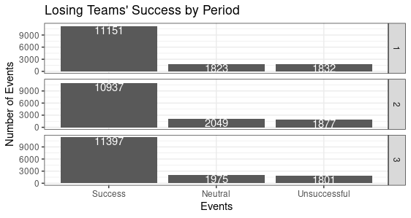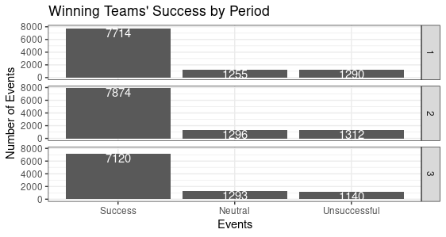

In an attempt to pinpoint specific events that winning teams thrive at, I looked at the occurrences of each type of event by period. Winning teams tended to score more goals in the second period than any other period, and losing teams had the fewest goals in the second period.

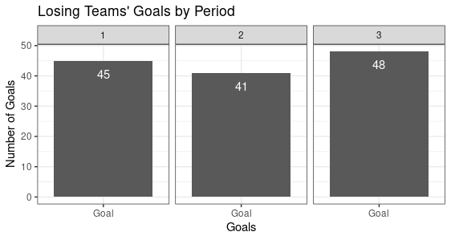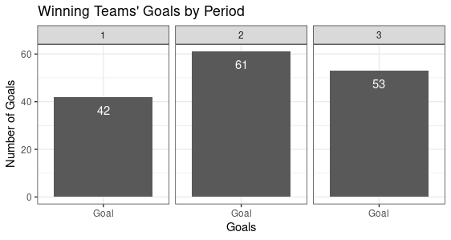

There was a large difference in how many takeaways winning teams had in the second and third periods from the first. Noticing this, I examined how many plays losing teams had and there seems to be fewer in the second period than any other period.

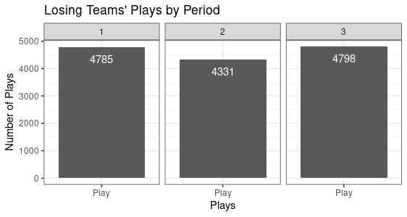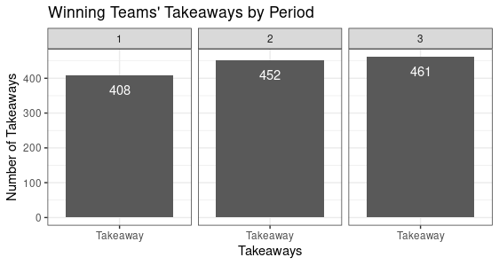

**Analysis**

Winning teams had more occurrences of any event in the second period. There are two potential explanations for this difference. One of these reasons is that winning teams pushed themselves harder in the second period to create more success. When comparing success across periods, the amount of success between the first and second periods does not differ much, but it varies more for the third period, with fewer successful events. The third period is also different because winning teams have more neutral events. The difference in success and the increase in neutral events indicates that winning teams put more effort into keeping the puck out of their defensive zone instead of scoring. This inference backs up McCurdy’s findings that teams who hold back have a bigger influence on score sequencing (McCurdy).

These differences could also be due to random chance. Due to this possibility, I decided to look at what specific events have significant differences. I found that winning teams score a lot in the second period and keep their opponents from scoring. Winning teams also have more takeaways in the second period, which allows them to have puck control. Should a team have more control over the puck, they are more likely to score, and have an easier time preventing other teams from scoring.

Losing teams tend to have more success in the third period. In fact, losing teams have the most occurrences of any type of event in the third period. Similar to how few occurrences indicate that a team is holding back, a lot of occurrences suggests that a team is pushing to have more events happen. From this, it can be inferred that losing teams understand that they could lose and are attempting to create every opportunity possible to score.

Interestingly, losing teams also have more total events than winning teams. This difference in total events is by thousands. As this study included every game, and there were no teams excluded from the study, I found this rather surprising as I expected the number of events to be relatively similar. I infer this to mean that winning teams were able to strategize a lot more than losing teams and hold back to execute this strategy; however, the true significance of this difference is unknown and should be studied further.

Each team attempts to perform well in the first period as that period is second highest for the occurrences of success. Winning teams do not need a lot of success in the third period as they are able to sit back, however losing teams need to force success. This difference is due to the separation that teams have in the second period, likely due to scoring and taking the puck away from opposing teams. Should a team score in the second period and have puck control, they could be more likely to win.

Due to physical exertion, the third period is also likely to be when a team’s physical abilities are lowest as players become tired, sore, or even hurt. A team that attempts to play their best game in the third period is making a risky bet. To avoid players having to stretch themselves when tired, a team should focus on the second period.

This research and further analyses could prove very important for scouts. Should they conduct a player-by-player analysis, they can find what players succeed the most in the second period. This information is valuable for trades, bringing a player up from the minor leagues to the NHL, and even potential draft picks. Recognizing these players could be the key to recognizing success.

**Conclusion**

Winning teams and losing teams had similar approaches in the first period, and opposite strategies in the third. A reason this difference exists is because teams that win succeed more in the second period, specifically in scoring and puck control. This allowed them to control the game and play to the strategy they wanted to. Teams should attempt to score aggressively in the second period, and from there on they should control the puck.

These findings are important for players and coaches because they can strategize and train better to succeed in the second period. The information is also important for scouting purposes because scouts can recognize players with the ability to succeed, specifically by scoring and causing takeaways, in the second period.

**References**

McCurdy, M. B. (2020, February 5). *Score sequencing*. https://hockeyviz.com/txt/scoreSeq.